CERT Emergency Communications

In this module you will learn about:
- The role of CERT in emergency communications
- How to use a communications plan
- Communications modes and technologies, including different phone and radio types
- An overview of basic two-way radios and how to use them
- How a CERT member participates in Net Operations
- Radio discipline techniques to encourage effective communication
- How to use tactical call signs
- How to make a call on a radio
- Proper radio use techniques

[This page intentionally left blank]

Introduction

Emergency Communications
Emergency communications is a system of coordinating people and transmitting information to first responders during an emergency. Emergency communications includes:
- The communication method or mode
- How the communicators organize themselves
- Techniques for effective communication in an emergency
Learning Objectives
At the end of this module, you will be able to:
- Describe the importance of communications in emergency response.
- Describe the role of CERT in communications during an activation.
- Describe how to use a communications plan.
- Describe the jurisdiction’s communications plan.
- Describe the CERT Communications Plan.
- Identify communications modes used in emergency response.
- Identify the advantages and limitations of different communications modes.
- Identify general regulations regarding various radio services.
- Describe how to properly communicate using communications devices.
- Describe the function of Net Operations in communications.
- Identify techniques for effective radio discipline.
- Describe tactical call signs and their purpose.
- Use tactical call signs and pro-words to make and acknowledge a call.

Introduction (Continued)

Why Is Emergency Communications Important?
During an emergency, effective communications is one of the greatest logistical problems. Without effective communications, first responders, including CERTs, will not know where to respond or what to expect. Without well-coordinated communications, an emergency response organization will be unable to effectively coordinate its resources. Without clear communications, responders may misunderstand a situation, responding to the wrong location or responding unprepared for the actual situation. Worse, if communications fails, first responders may find themselves in danger for which they are unprepared.
Successful communications is essential to successful emergency response, while problematic communications may actually make the situation worse. Effective, clear, organized communications is essential in an emergency response.
CERT volunteers will be part of a communications network when participating in an emergency response, whether you are serving as a runner or coordinating multiple teams as a Net Control Operator. Having some basic familiarity with communications modes and techniques and an overview of how CERTs fit into the communications plan will go a long way towards ensuring that CERTs remain a part of the solution, rather than complicating the problem.

Introduction (Continued)

Communications in Actual Disasters
Next you will look at the role communications played in real emergency response situations.
Hurricane Katrina
Coordination of the rescue efforts on August 28-29, 2005 were hindered by failures in the local communications system. Most cell phones, landline telephones, and Internet connections were inoperable due to line breaks, destruction of base stations, or power failures.
9/11
During the terrorist attacks of September 11th, problems with emergency communications caused significant hindrances for first responders. Here are just a few of the problems:
- Firefighters in the first building were unaware the second building had collapsed.
- Volunteer first responders entered the scene without radios and thus were unable to receive updated information about the status of the buildings.
- Cell phone and landline systems were quickly overloaded, making it difficult or impossible for citizens to contact their family members.
- Conflicting instructions from 9-1-1 and public safety workers in the buildings resulted in confusion among evacuees.
Mineral, VA
On August 23, 2011, a magnitude 5.8-6 earthquake 84 miles southwest of Washington, D.C. resulted in an overload of cell phone networks from North Carolina to New York. Although the quake caused no major damage, there were simply too many callers on at the same time.

Introduction (Continued)
Module Overview
This module will cover the following topics:
- Role of CERT emergency communications during an activation: You will learn about what sorts of communications activities they may be involved with during an activation.
- Communications plans: You will learn what a communications plan is and how to use it. You will also learn details about local jurisdictional and CERT Communications Plans.
- Communications modes: You will learn about various communications modes, especially those likely to be used by their CERT.
- Basic radio anatomy: You will become familiar with basic handheld radios.
- Communications operations: You will learn effective communications techniques and how to participate in Net Control Operations.
- Practical exercises: You will practice radio communications using the protocols and techniques you have learned.

Role of CERT in Emergency Communications

Intra-Team Communications
One communications function that you will participate in during an activation is intra-team communications. Effective intra-team communications allows volunteers to quickly and effectively communicate to one another. It is a critical component of tasks such as light search and rescue. Intra-team communications may be as simple as sending runners from one group to another, or may involve the use of handheld radios and transmitting using Net Control protocols.
Communicating Up to the Next Level
One of the most important roles that CERT volunteers fulfill is acting as “eyes and ears.” CERT volunteers, working alongside professional emergency responders during an emergency, are expected to be able to communicate back to the professionals. In this way, the professionals can be dispatched to where they are most needed, and the CERT volunteers act as “force multipliers” for the professional responders.
However, each volunteer cannot simply radio all emergency personnel at the moment he or she needs them. This would rapidly devolve into chaos. Instead, each CERT and jurisdictional office of emergency management has its own protocols for how emergency response groups coordinate communication. This is called a communications plan, and it defines who talks to whom.
Communications Promotes Safety
One of the most important functions of communications is to promote safety—both the safety of the responder as well as the safety of the individual affected in an emergency. An effective communications network allows:
- A responder to quickly call for help when it is needed.
- A responder to notify others of potential safety concerns in the area.
- A team leader to keep track of volunteers; this is called accountability.

Communication Plans
What Is a Communications Plan?
When communicating in small groups of four or fewer, a structure is not particularly needed. However, when multiple teams work together on a larger incident, and those teams must coordinate with other emergency response organizations, we need a plan.
A communications plan is a document that defines communications roles and establishes protocols for different groups during an emergency. Each community or jurisdiction will have its own communications plan.
CERTs also have a communications plan. The CERT Communications Plan is a function of the jurisdictional communications plan and includes details such as how CERT volunteers are contacted during an activation and what radio channels they have available for communication.
Jurisdiction Communications Plan
A community or jurisdictional communication plan is defined by the local or regional office of emergency management. It defines what organizations use what radio channels in the event of an emergency. It also establishes clear rules for who can communicate with whom. These are necessary logistical rules in order to ensure that communications channels are not flooded and responders are not drowned in irrelevant chatter, and that communications lines are open and available when they are needed.
- The CERT’s place in the plan

- Other important emergency responders

- How the CERT communicates with emergency responders

- CERT’s sponsoring agency

Communication Plans (Continued)

CERT Communications Plan
The CERT also has a communications plan. This plan is based on the Incident Command Structure (ICS) that you learned about in CERT Basic Training.
A CERT Communications Plan explains:
- How the CERT is activated and volunteers are contacted.
- How volunteers in the same CERT communicate.
- How volunteers in different CERTs communicate.
- How the CERTs communicate to other emergency responders.
- How the CERT fits into the jurisdiction’s plan.
The Local CERT Communications Plan
- Roles CERT might play in communications

- How your CERT communicates with other emergency responders

- What you need to know about the local CERT Communications Plan

An ICS 205 form is from the National Incident Management System (NIMS) and is used in an emergency to detail roles and tasks as a part of the CERT Communications Plan. You can see a blank ICS 205 form on the next page.

Communication Plans (Continued)

ICS 205
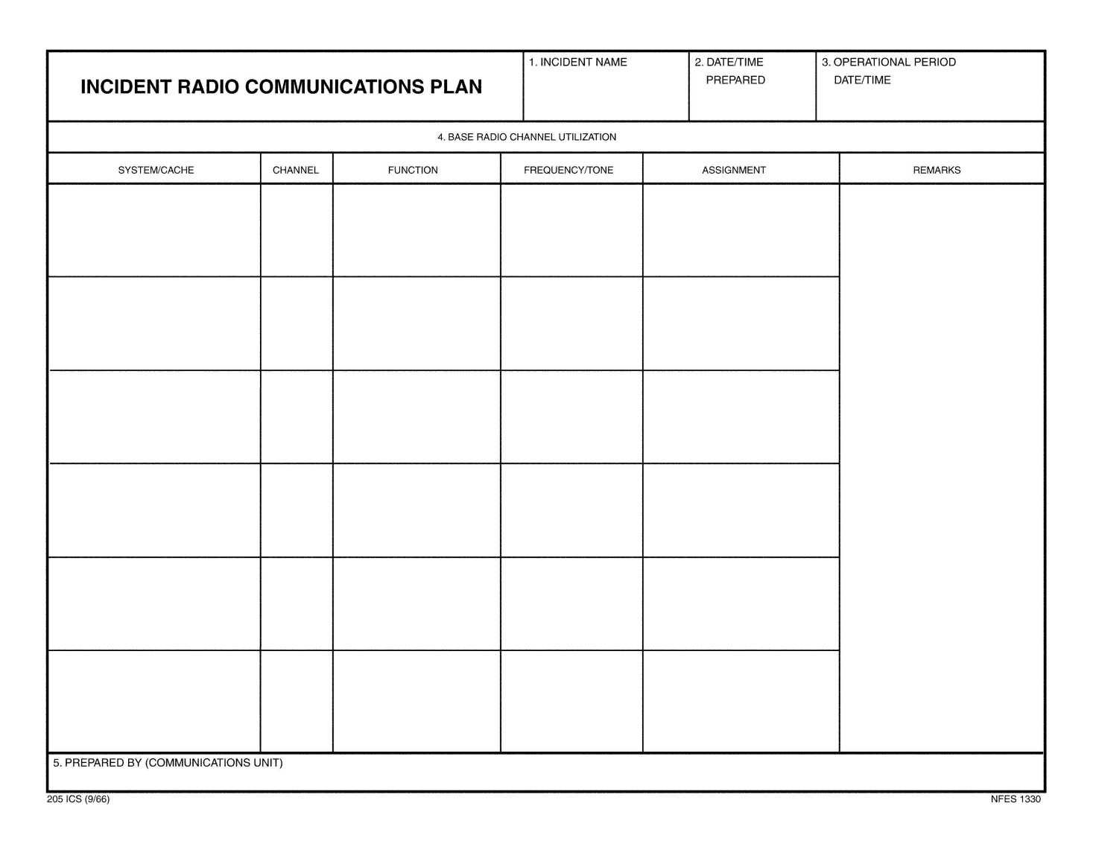

Communication Plans (Continued)
Communications Plan Diagram Activity
This diagram is a scheme of the basic relationships a communications plan is meant to define. In this particular example (a very simple one), we have two response teams, A and B. In this basic diagram, the light blue circle in the center represents the Command Unit.
Fill in the blanks of this diagram as the class answers the questions.

Note that while the members of each team can communicate directly with one another, only the team leader can communicate with Command, and only Command can communicate with other agencies.
The Command may instruct individual team members or team leaders to contact another team or an emergency response agency directly. How this happens will be discussed later under Net Control Operations.
The next topic will cover methods and devices for communicating.
Communications Plan

Communication Modes
A communications mode is a technology or method for communicating. Each communications mode has its own particular advantages and limitations.
A CERT will focus on the use of a few different communications modes, but it will be helpful to be familiar with all of them in the event that you encounter them during an activation.
Communication modes can broadly be categorized as runners, phones, radios, and computers.

Overview
The main communications modes that will be covered in this section include:
- Runners: Individuals carrying written messages from one location to another
- Landline telephones: Analog and digital phones connected by physical lines
- Cellular phones: Mobile digital phones connected by signals transmitted by cellular phone towers; many are capable of transmitting lower bandwidth text messages
- Two-way radios: Handheld, mobile, or base-station radios used for communicating on radio frequencies; many require licensure by the FCC
- Electronic: Computer-based communications that may be transmitted over the Internet or with runners via USB drives, floppy disks, or CD-ROMs
- Satellite phones: Mobile phones that use signals transmitted by satellites
See the Appendix at the back of this Participant Manual for a quick reference to the different modes of communication.

Communications Modes (Continued)
Runners
Runners are volunteers who carry messages from one location to another. Runners are extremely reliable, since they can operate in situations that would otherwise disable other communications systems.
Where possible, use people who are not doing anything else to help out as runners; otherwise you will deplete your pool of trained volunteers.
Always have runners carry written messages in order to avoid miscommunication.
Advantages
- Reliability
- Flexibility
- Familiar with environment
- Availability
- No special training
Limitations
- Distance and time
- Requires written information for accuracy
- Availability (deplete your team)
- Requires familiarity with the area

Communications Modes (Continued)
Landlines
Landline telephones, especially analog phones, may operate during power failures, as they are powered by the phone line itself. Handheld phones may only last as long as their batteries, and digital phones may or may not work, depending on the model.
Many communities now have Enhanced 9-1-1, enabling 9-1-1 operators to lock onto your location by providing them your address and phone number.
Be aware that local telephone systems typically cannot handle a load of more than 10% at any one time. That means that if more than 10% of the people in an area attempt to use the phone at the same time, the system will overload and fail.
Advantages
- Familiarity
- Commonplace
- Enhanced 9-1-1
- Data transfer
Limitations
- Not mobile
- System overloads easily
- Network can sustain physical damage
- Power failure may/may not affect
- Corded phones vs. cordless phones
- Digital phones
- Voice Over Internet Protocol (VOIP)

Communications Modes (Continued)
Cell Phones
The greatest advantages of cell phones as communications devices are that they are commonplace and that they are mobile. Most cell phones are also able to transmit text messages. In the event of a system overload or a weak signal, a text message may get through when a voice message will not. This is because a text message requires far less bandwidth than voice.
In contrast to common belief, cell phones do not communicate via satellites. Instead, they transmit signals that are relayed by cell phone towers. Sometimes this involves retransmitting the signal; sometimes it involves rerouting the signal into a landline. Therefore, cell phones are vulnerable to the same sorts of weaknesses as telephones. Additionally, cell phone networks require electricity, since the towers themselves require electricity to operate.
Cell phone networks are also easily overloaded during times of high demand. Another problem with using cell phones in emergency communications is that first responders must have each other’s cell phone numbers. For those volunteers using cell phones during an emergency response, it is recommended that hands-free headsets and microphones be used.
Advantages
- Familiarity
- Mobility
- Commonplace
- Text messaging
- Requires less bandwidth – may get through when voice will not
- Camera phones
Limitations
- Towers may fail due to power outage or damage
- System overloads easily
- Requires knowledge of phone numbers
- May be dependent on landlines

Communications Modes (Continued)
Satellite Phones
When other phone systems are down, satellite phones will only be able to communicate locally with other satellite phones. Satellite phones are typically available to and used by large emergency responders, such as FEMA. Satellite phones range in price from $750 to upwards of several thousand dollars.
Advantages
- Always on
- Global operation
Disadvantages
- Expensive
- Rare
- Requires visibility to sky, or building with compatible antenna
Computer Communications
Computer communications includes e-mail, photos, video, audio, formatted documents, or other data transmitted via the Internet or by runners using USB drives (commonly known as “thumb drives”) or other media such as CDs.
One of the overlooked advantages to using computers for communication is the ease of mass distribution. Using e-mail, alerts, notices, preformatted documents, and other information can be sent out to any number of participants with a single click.
While laptops are portable, they may not be ideal for use in emergency response situations due to their size. Also, both senders and receivers have to have functioning, specialized equipment in order to communicate using computers. Receivers must also be monitoring such equipment. It doesn’t help to e-mail a team leader a photo of a dangerous situation if that team leader doesn’t have immediate access to e-mail.

Communications Modes (Continued)
Advantages
- May work when other systems are down
- Provides electronic record
- Versatile network connections
- Relatively secure
- Large amounts of information
- Formatted/preformatted information
- Thumb drives and discs do not require Internet
- Information redistribution
Limitations
- Equipment may not be mobile
- May require Internet connectivity
- Requires specific hardware
- Expensive
- Requires power source

Communications Modes (Continued)
Two-way Radio
Two-way radio is a communications mode that does not rely on external power supplies or physical communications infrastructure. This makes two-way radios a good communications mode during an emergency.
Two-way radios include a variety of devices and are often defined by the frequencies (or channels) they are designed to operate on. Radios capable of more powerful transmissions typically require a license from the FCC.
There are several organizations involved with two-way radios that are important to know about.
- The Federal Communications Commission (FCC) regulates licensure and allocation of bandwidths. Many two-way radios require an FCC license to use.
- The American Radio Relay League (ARRL) provides training and testing for amateur radio licenses and other radio emergency service functions.
- Amateur Radio Emergency Services (ARES) operators volunteer to provide communications services via amateur radio during emergences. These operators are organized by regional coordinators to serve that function, and thus may be involved in the CERT Communications Plan.
- Radio Amateur Civil Emergency Services (RACES) operators perform a similar function to ARES operators, only they are specifically sponsored by the government.

Communications Modes (Continued)
How Do They Work?
Two-way radios operate by transmitting and receiving on certain frequencies. No one owns or has exclusive rights to a frequency, but the FCC determines who can use them and when.
On radios, frequencies are typically divided into a number of discrete channels. Since only one person can speak on a channel at a time, more channel availability means that more conversations can happen in the area. Each team is typically assigned a channel to use as part of the communications plan.
The ranges of the radios discussed here depend on a wide variety of factors. Actual performance will depend on the area terrain and atmospheric conditions. Keep in mind that the printed claims on the box are advertising and not a guarantee of regular performance.
The range of a radio can be increased by using a better antenna or a repeater. A repeater is a regional transmitter that picks up radio signals and retransmits them, essentially extending their range.
If a radio is not using a repeater to transmit, the radio is said to be in “simplex” mode. Radios operating in simplex mode are usually limited to line-of-sight distances.
Family Radio Service (FRS)
FRS radios are simple, basic, two-way radios that are good for intra-team communication between CERT members. FRS radios do not require a special license by the FCC. Many people have FRS radios; however, they are becoming increasingly difficult to purchase new. Most radios now available are FRS/GMRS hybrids (which will be covered later).
FRS radios have a very limited range, which makes them useful only for intra-team communications. It is against FCC regulations to boost the signal of an FRS radio with an antenna or repeater.

Communications Modes (Continued)
Advantages
- Inexpensive
- Widely used
- No license required
- Range up to 1 mile (varies with terrain)
- 14 channels
- Shared communication with GMRS radios
- Best used for intra-team communications
Limitations
- Limitations
- Hard to find (most are hybrids)
- Handheld only
- Cannot alter radio (no antennas) = Limited range
General Mobile Radio Service (GMRS)
GMRS radios have a greater range than FRS radios, and their signals can be improved with antennas and repeaters. They are very useful for intra-team communications.
Using a GMRS radio does require an FCC license. In addition, due to the predominance of hybrid radios in the marketplace, GMRS radios are no longer widely available for purchase.

Communications Modes (Continued)
Advantages
- Inexpensive
- Range of 2-5 miles (varies with terrain)
- Best used for intra-team communications
- Base station or mobile
- Boost signal with external antennas or repeaters
Limitations
- Requires a license (one per family)
- Intended for family use
- Some business licenses are grandfathered
- Limited availability (hybrids)
FRS/GMRS Hybrid
FRS/GMRS hybrid radios are inexpensive and commonly available two-way radios. They are designed so that they can be operated on FRS or GMRS frequencies and include seven shared channels. They have all the advantages and limitations of an FRS and a GMRS radio, depending on which mode is being used.

Communications Modes (Continued)
Multiple-Use Radio Service (MURS)
MURS radios are a newer type of two-way radio. They are more powerful than GMRS radios, they can be used with repeaters and external antennas, and no license is required for their use.
Unfortunately, MURS radios are more expensive than FRS/GMRS radios, only five channels are available for use (as opposed to 22 on a hybrid), and not many people have them, making it difficult to communicate with other users.
Advantages
- Handhelds or base units available
- 3-4 mile range for handhelds
- Increase range with repeaters and external antennas
- Transmit voice or data
- No license required
Limitations
- Limited to 5 channels
- Limited availability
- More expensive than FRS/GMRS radios

Communications Modes (Continued)
Citizen Band (CB)
CB radios have no license requirement and have a large number of channels; however, due to the frequency that they operate on, they are practically useless for short-range transmissions.
CB radios are not recommended for CERT use.
Advantages
- No license required
- 40 channels
Disadvantages
- Casual conversation
- Not reliable
- Not recommended for CERT use

Communications Modes (Continued)
Public Safety Bands
Emergency dispatchers, fire fighters, EMS, police, and other government emergency responders use a special high-powered mode called public safety bands.
Public safety bands are licensed to municipal governments and require the authorization of the municipality in order to use.
Advantages
- Direct communication to emergency first responders, if authorized
- Extremely reliable
- Range up to 20 miles with simplex, 50 miles with repeaters
- Handheld, mobile, or base units
Limitations
- Requires authorization of jurisdiction
- Expensive
- Must be used with jurisdictional protocol
- Licensed to municipality or government entity

Communications Modes (Continued)
Amateur Radio (a.k.a. ham radio)
Also known as “ham” radio, amateur radio is a very reliable communications method employed during emergency response situations. Amateur radios are widely available in a variety of configurations and can be used to transmit in excess of 100 miles using repeaters and antennas. Amateur radios require a license from the FCC. This requires studying for and passing a relatively inexpensive exam. Amateur radios are complex devices with elaborate protocols; users must study and practice to learn how to use them properly.
Advantages
- Various data types (voice, text, data, photos, documents, e-mail, television)
- Range in excess of 100 miles with repeaters
- Operate using simplex or repeaters
- Good availability
- Moderately priced
- Handheld, mobile, and base stations available
- Reliability
- Interoperability
- More simultaneous conversations possible
- Connect to computer
- Connect to global positioning system (GPS) and automated position reporting system (APRS)
Limitations
- Requires license
- No business use
- Operators cannot be paid
- Complex radios
- Complex protocols

Basic Radio Anatomy
Avoid turning your radios on, as the amount of noise is liable make the class very chaotic.
The type of communications device recommended for purchase by CERT volunteers interested in radio communications is _____________________________________.
This recommendation is not a requirement. The recommendation should be in accordance with the CERT Communications Plan.
The first thing you should do with a radio before using it is READ THE MANUAL!
Owners should practice using the radios regularly to be familiar with the two-way radio when it is needed.
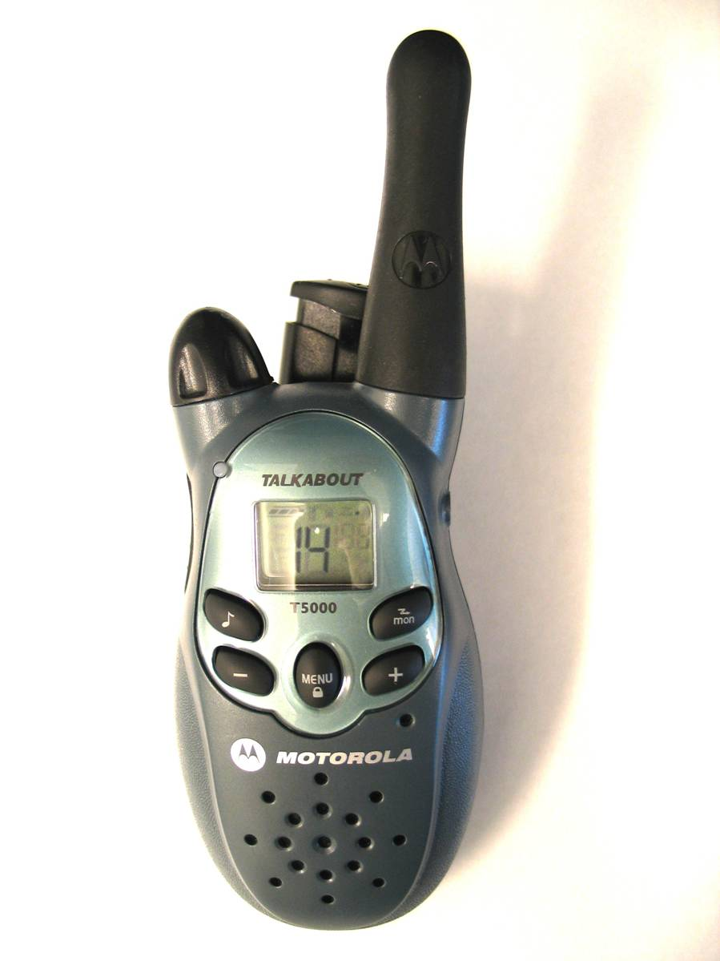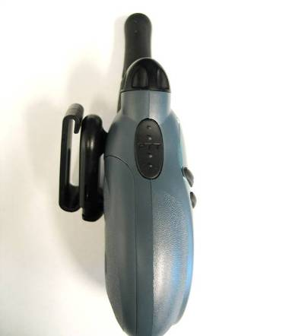
Volume & On/Off Switch
Push-to-Talk Button (PTT)
Antenna
Speaker
Microphone

Basic Radio Anatomy (Continued)
The basic controls on the radio include:
- On/off switch
- Volume control
- PTT button (Push to talk)
- You must press down the PTT button while you are speaking.
- Remind participants that they must release the button to listen!
- Antenna: Hold it vertical for best reception
- Speaker
- Microphone
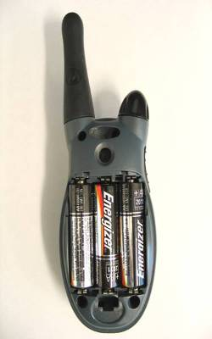
Headset Input Jack
Channel Selector
Channel Monitor
Scan Button
Transmit Call Tone
Battery Location
Privacy Line (PL) Selector
& Lock Settings

Basic Radio Anatomy (Continued)
The advanced features of the radio include:
- Battery location
- Channel selector
- Channel monitor
- Headset input jack
- Privacy line selector
- Lock button
- Transmit call tone
Additional features on the radio include:
- Monitor button
- Ring tone selector
- Power settings selector
Battery Location
Find the location of the battery on the radio. Learn how to change the battery and how to recharge the battery. Find out whether battery substitution is possible.
A radio is practically unusable while it is charging; therefore you should always carry extra batteries when working with the radio. Avoid overcharging the radio, as this can damage the unit!
SAFETY NOTE: Never attempt to recharge alkaline batteries!
Privacy Codes
Most radios are equipped with a privacy line selector. Despite what the name suggests, these “privacy codes” do not make your conversation private. All a privacy code does is block you from hearing other conversations on that channel.
Privacy codes are not standard between different brands of radio. Privacy codes are not recommended for CERT use.

Basic Radio Anatomy (Continued)
Practical Exercise: Using a Radio
Purpose: This short exercise allows you to practice using your radios.
Instructions:
- You have 3 minutes to turn on the radios and experiment with their use.
- If you are using FRS/GMRS hybrid radios, remain on FRS-only channels.
In the next part of the lesson, you will learn how to use the radios in an activation.

Communication Operations

Net Operations
Net Operations, or a Controlled Net, is a system for coordinating communication among groups of four or more people.
Details of how a Controlled Net functions is typically defined in a communications plan, but the way it works is like this:
As long as a small team is communicating among themselves, they use standard radio protocol. However, once a team needs to contact either another team, report into a command unit, or contact another emergency response agency, they need to contact a Net Control Operator.
A Controlled Net has one or more Net Control Operators. The Net Control Operator is essentially a radio “traffic cop.” When you call a Net Control Operator, the operator will:
- Direct you to call whomever you need to speak to.
- Direct you to stand by.
- Direct you to a different radio channel.
- Prioritize calls based on the nature of the message.
A Net Control Operator is functioning as the “brain” of a communications network. Large networks may require several networks of Net Control Operators.

Communication Operations (Continued)
Practical Exercise: Net Operations
Purpose: To consider different possibilities for setting up a radio communications net for a single neighborhood CERT during an incident. Each group will then chart the radio net that the group agrees would be most advantageous to the CERT in the scenario. Each group will have the same scenario and 10 minutes to review the scenario, answer the questions to create a net plan, and then chart their plan (or fill out the ICS 205 form). After 10 minutes, each group will pick a spokesperson to describe that group’s net operations plan.
Instructions:
- Break into five or six small groups.
- Refer to the communications net scenario on the next page.
- Elect one volunteer to read the scenario aloud for your group.
- Answer the questions on pages 31 and 32 as a group. Use the space provided to write your solutions.
- You have 10 minutes to perform this exercise.

Communication Operations (Continued)
Scenario
It is a Saturday afternoon in November. During the morning hours, a severe storm hit the community with unexpected force. Winds in excess of 50 mph have brought down trees and power lines all over the city. Many roadways are blocked by trees and other debris from the storm. It is 1:30 p.m. and the storm has ended.
Following the city’s protocol, your neighborhood CERT, “SW CERT,” has activated and nine Team members have been able to show up at the pre-designated meeting place. Six untrained neighbors have also arrived and are willing and able to help. A command post has been established at 7th St. & Oak. The Team Leader has been identified.
The Team Leader has identified Team members for the following positions: Operations Leader, Search and Rescue Group Leader, Medical Group Leader, and Command Post Radio Operator. Each person will communicate via amateur radio.
Following the city’s protocol, the Team Leader has had the Command Post Radio Operator inform the city’s Emergency Operation Center that the SW CERT is in action and operating from 7th St. & Oak.
Based on initial damage assessment performed by Team members, the CERT’s first priority is the community center, which had been damaged during the storm. Eight people who had been at a class at the community center and decided to remain there to wait out the storm were injured when a tree came through the window. They are being moved by the Search and Rescue Group to a treatment area in an undamaged part of the building. The Medical Group is taking care of the victims there.

Communication Operations (Continued)
Scenario Questions
At this point in the operation:
In addition to the city’s Emergency Operation Center, with whom does the Team Leader of SW CERT need to communicate?

With whom does the Operations Leader of SW CERT need to communicate?

With whom does the Search and Rescue Group Leader of SW CERT need to communicate?

With whom does the Medical Group Leader of SW CERT need to communicate?

Given the current communications needs, should the SW CERT set up Net Operations?

Communication Operations (Continued)
The EOC radios the Team Leader with two messages:
- A sparking downed power line has been reported just two blocks from the SW CERT’s command post. Could the CERT check it out immediately?

- CERT members from an adjoining neighborhood are able to assist the SW CERT if help is needed.

The Team Leader acknowledges both messages and sends a CERT member with two of the untrained volunteers to check out the downed power line.
- In addition to the city’s Emergency Operation Center, with whom does the Team Leader of SW CERT now need to communicate?

- With whom does the Operations Leader of SW CERT now need to communicate?

- Given the current communications needs, should the SW CERT set up Net Operations now?

Communication Operations (Continued)

Tactical Call Signs
Instead of using names, part of Net Operations is to use tactical call signs.
A tactical call sign is a designation assigned to a team or an individual based on function or location. Tactical call signs are assigned by a Net Control Operator and are made for the duration of an assignment.
FCC licensed services such as ham operators will add their official call sign to this exchange when and where required by FCC rules.
Tactical Call Signs – Making a Call
To transmit and acknowledge calls using tactical call signs, follow these steps:
- To make a call, give the other person’s tactical call sign first, then your tactical call sign, then the word “over.”
- To acknowledge a call, give the call sign of the person calling you, then say, “This is” then give your call sign, then say “over.”
- Next, transmit the message. Always identify yourself when you are transmitting the message.
- The receiver should acknowledge receipt by identifying him- or herself, repeating the gist of the message, and then saying “over.”
- The transmitter then terminates the message by identifying him- or herself and then saying “out.”

Communication Operations (Continued)
Practical Exercise: Tactical Call Signs Demonstration
Purpose: This short exercise will demonstrate how tactical call signs are used.
Instructions:
- Two volunteers will come to the front of the class. One of the volunteers will get the Tactical Call Sign Demonstration Script A, and the other one Script B.
- The volunteer with Script A will read the first bullet point on the script.
- The volunteer with Script B should respond by reading the first bullet point on his/her script.
- The two volunteers should continue alternating back and forth until the message is completed.
Tactical Call Sign Demonstration Script A
Southwest CERT Command
NOTE: You are calling EOC. You will initiate the call.
- EOC, this is Southwest CERT Command, over.
- EOC, this is SW CERT Command. Send 22 stretchers to corner of 12th Street shelter near CVS, over.
- EOC, this is SW CERT Command, out.
Tactical Call Sign Demonstration Script B
EOC
NOTE: You are responding to a call from Southwest CERT Command. They will initiate the call.
- Southwest CERT Command, this is EOC, over.
- SW CERT Command, this is EOC, 22 stretchers at 12th Street shelter, over.
You will have opportunities to practice an activity like this later in the module.

Communication Operations (Continued)

Radio Use
This part of the training will teach you good techniques for improving reception and transmission quality.
- Speak across the radio microphone rather than directly into it in order to produce a clearer message.
- Use the “echo principle.” Repeat essential parts of the message to the sender.
- Keep the antenna in a vertical position.
If you have poor reception, try elevating your radio, or stand on a stable elevated surface.
If you are in a structure, try moving near an open window or moving to another area of the structure.
If your radio is in your pocket or on your belt and you have poor reception, try to raise the radio above your body, as your body can interfere with signal reception. Also, try rotating slowly to see if the signal clears.

If you have poor reception in a vehicle, stop the vehicle, and then try raising the antenna above the vehicle or moving away from the vehicle.
- Team radios should be equipped with a headset with a microphone whenever possible. This will enable the CERT volunteer to keep both hands free while sending and receiving messages.
- Always keep radios turned on. Monitor your radio for safety, accountability, and intra-team communications.

Communication Operations (Continued)
Pro-Words
Familiarize yourself with these words which are commonly used in radio transmissions:
- “All before X” – Repeat everything prior to X (a word in the message).
- “All after X” – Repeat everything after X (a word in the message).
- “I spell” – Say prior to spelling a difficult or ambiguous-sounding word.
- “Affirmative”
- “Negative”
Phonetic Alphabet
Radio operators use code words to spell out difficult or ambiguous-sounding words. This is called using a phonetic alphabet.
You are going to practice using the phonetic alphabet.

Communication Operations (Continued)
Practical Exercise: Phonetic Alphabet
Purpose: To familiarize you with using a phonetic alphabet.
Instructions:
- A participant at one side of the class will spell the first name of a family member phonetically, using the phonetic alphabet below.
- The rest of the class will translate the name from the phonetic alphabet back into a written alphabet. You can use the space provided on the next page to write down the translation.
- Repeat until everyone in the class has had an opportunity to spell a name phonetically.
Phonetic Alphabet
A--Alfa  B--Bravo  C--Charlie  D--Delta  E--Echo  F--Foxtrot  G--Golf  H--Hotel  I--India | J--Juliet  K--Kilo  L--Lima  M--Mike  N--November  O--Oscar  P--Papa  Q--Quebec  R--Romeo | S--Sierra  T--Tango  U--Uniform  V--Victor  W--Whiskey  X--X-ray  Y--Yankee  Z--Zulu

Example: If the participant decided to spell the name of his brother “Frank,” he would say aloud:
Foxtrot – Romeo – Alfa – November – Kilo
The other participants should write the name “Frank” on the blank page in their Participant Manuals.

Communication Operations (Continued)
Practical Exercises – Role-playing 1
Purpose: To allow you to practice all of the techniques you have learned.
Instructions:
- Divide into pairs for this practical exercise, a role-playing activity. Move around the room so that you are not standing next to one another.
- Each “Small Scenario Role-playing Card” contains two tactical call signs, one for the caller and one for the receiver. Each card also contains a brief scenario.
- One participant should be the caller; the other will be the receiver.
- The caller should examine his scenario, then make a call to the receiver and transmit the information, then terminate the transmission.
- The receiver should acknowledge the call and verify the message.
- Don’t speak too loudly in order to avoid disrupting the other participants.
- After you complete the exercise, switch roles and repeat it. Then trade role-playing cards with your neighbors and repeat the exercise again.
- Be sure to use:
- Tactical call signs
- Pro-words
- Phonetic alphabet
- Echo principle
- Good radio protocol

Communication Operations (Continued)
Practical Exercises – Role-playing 2
Purpose: You will practice operating in a group with a leader.
Instructions:
- Five volunteers go to the front of the class.
- A sixth volunteer is assigned the role of Net Control Operator. This role should be played by an experienced amateur radio operator (if there is one in the class).
- Among the initial five volunteers, one will be assigned the role of IC/CERT Leader.
- Read the sample scenario below.
- The volunteers play out a scenario. The Command unit should ask the Willow Park CERT Leader for a status check on his team. The Leader should call for a status check on each team member. As much as possible, volunteers should attempt to communicate using tactical call signs, Net Operations protocol, and other proper radio use techniques.
Scenario – Injured Animal Encounter
The CERT is conducting damage assessment in the Willow Park area. Team 1 has not found anything worth noting. Nearby, team 2 was approaching a footbridge and discovered that high waters had damaged the structure of the bridge. Team 3 is checking for civilians in the picnic area and has found a leftover picnic basket but no people. Team 4 has just spotted an injured dog that is limping but does not appear to be acting threatening towards the volunteers.
- Critique the scenario by identifying what worked and what could have been done better.

Communication Operations (Continued)
Continuing the Exercise:
- A new group of volunteers will be needed.
- The rest of the class can call out ideas for a scenario that would involve some basic communication.
- The instructor will write the ideas on an easel pad.
- Once a single scenario has been fleshed out significantly to create a communications situation, the role-players will act it out.
- Repeat this exercise until everyone in the class has had an opportunity to act as a role-player.

Summary
- Communications is a key component of emergency response. Effective communications allows for effective tactical emergency response. Ineffective communications will result in poorly managed emergency response and may result in increased dangers to the responders or civilians in the emergency.
- CERT volunteers act as the “eyes and ears” for other emergency response agencies by communicating through the ICS.
- A communications plan defines how different levels communicate during an emergency response situation.
- Different communications modes have different advantages and limitations during an activation.
- Effective communications can be achieved by knowing how to operate a radio, using tactical call signs, using pro-words, using the phonetic alphabet, and using some basic protocols.
- For more information about amateur radio, contact your local amateur radio club to find out about licensure training.

[This page intentionally left blank]

Appendix

[This page intentionally left blank]

Communications Modes Table

Mode of Communication |  | How it works | Reliability | Availability | Advantages | Limitations
Runners |  | Volunteers carry messages from one location to another | Extremely reliable | Any reliable person can be used as a runner | - Reliability  - Flexibility  - Familiar with environment  - Availability  - No special training | - Distance and time  - Requires written information for accuracy  - Availability  - Requires familiarity with the area
Landline Telephones |  | Phones that are powered by themselves and rely on local telephone lines | - May operate during power failures, but handheld batteries can die and digital phones may or may not work  - Local telephone system generally fails when a large number of people in an area attempt to use phone at the same time | Very common | - Familiarity  - Commonplace  - Enhanced 9-1-1  - Data transfer | - Not mobile  - System overloads easily  - Network susceptible to physical damage  - May be affected by power failure
Cellular Phones |  | Phones that transmit signals relayed by cell phone towers | - Vulnerable to the same weaknesses as telephones  - Cell phone towers require electricity to operate | Very common | - Familiarity  - Mobility  - Commonplace  - Text messaging | - Towers may fail due to power outage or damage  - System overloads easily
 |  |  | - Local service (voice) generally fails when a large number of people in an area attempt to use service at the same time |  | - Requires less bandwidth – may get through when voice will not  - Camera phones | - Requires knowledge of phone numbers  - May be dependent on landlines
Satellite Phones |  | Relays transmissions via satellite. | If other phone systems are down, can only communicate locally with other satellite phones | Rare | - Always on  - Global operation | - Expensive  - Rare  - Requires visibility to sky or building with compatible antenna
Computer Communications |  | Transmits data via the Internet or by runners using USB drives or other media such as CDs | - May work when other systems are down | Very common | - May work when other systems down  - Provides electronic record  - Versatile network connections  - Relatively secure  - Large amounts of information  - Formatted/pre-formatted information  - Thumb drives and discs do not require Internet  - Information redistribution | - Equipment may not be mobile  - May require Internet connectivity  - Requires specific hardware  - Expensive  - Requires power source
Two-way Radios | Family Radio Service (FRS) | Radios that transmit and receive on certain frequencies | Have a very limited range; useful only for intra-team communications | Common, but becoming increasingly difficult to purchase new | - Inexpensive  - Widely used  - No license required  - Range up to 1 mile  - 14 channels  - Shared communication with GMRS radios  - Best used for intra-team communications | - Hard to find  - Handheld only  - Cannot alter radio (no antennas) = limited range
 | General Mobile Radio Service (GMRS) | Radios that transmit and receive on certain frequencies | - Have a greater range than FRS radios  - Signals can be improved with antennas and repeaters | New GMRS only radios are not widely available for purchase | - Inexpensive  - Range of 2-5 miles  - Best used for intra-team communications  - Base station or mobile  - Boost signal with external antennas or repeaters | - Requires a license (one per family)  - Intended for family use  - Some business licenses are grandfathered  - Limited availability
 | FRS/GMRS Hybrid | Radios designed to be operated on FRS or GMRS frequencies | Have a greater range than FRS or GMRS radios with 22 channels available  Have all of the advantages/disadvantages of FRS and GMRS radios because both FRS and GMRS have been combined into one radio | Commonly available; users must have a license to operate on the GMRS channels | Same advantages as FRS and GMRS, depending on which mode is used | Same limitations as FRS and GMRS, depending on which mode is used
 | Multiple-Use Radio Service (MURS) | Radios that can be used with repeaters and external antennas | Only 5 channels available for use | Hard to find at general commercial retail stores; more available at hobbyist stores specializing in communications | - Handhelds or base units available  - 3-4 mile range for handhelds  - Increase range with repeaters and external antennas  - Transmit voice or data  - No license required | - Limited to 5 channels  - Limited availability  - More expensive than FRS/GMRS radios
 | Citizen Band (CB) | Radios that transmit and receive on public frequencies | Have 40 channels, but due to frequency they are practically useless for short range transmissions | Common | - No license required  - 40 channels | - Casual conversation  - Not reliable  - Not recommended for CERT use
 | Public Safety Bands | A special high-powered communication mode used by emergency dispatchers, fire fighters, EMS, police, and other government emergency responders | Extremely reliable | Limited; must be used with jurisdictional protocol | - Direct communication to emergency first responders, if authorized  - Extremely reliable  - Range up to 20 miles with simplex, 50 miles with repeaters  - Handheld, mobile, or base units | - Requires authorization of jurisdiction  - Expensive  - Must be used with jurisdictional protocol  - Licensed to municipality or government entity
 | Amateur Radio | Available in a variety of configurations; transmit using repeaters and antennas | Very reliable | Widely available | - Various data types (voice, text, data, photos, documents, e-mail, television)  - Range in excess of 100 miles with repeaters  - Operates using simplex or repeaters  - Good availability  - Moderately priced  - Handheld, mobile, and base stations available  - Reliability  - Interoperability  - More simultaneous conversations possible  - Connect to computer  - Connect to global positioning system (GPS) and automated position reporting system (APRS) | - Requires license  - No business use  - Operators cannot be paid  - Complex radios  - Complex protocols  - Must work with existing area Emergency Communications Plans

